Sprint 1, evidencias

[JUAN FELIPE JIMENEZ SALAZAR](mailto:juan_felipe.jimenez@uao.edu.co), SCRUM MASTER SISTEMA LMS

[GABRIEL NNGEL JEANNOT VIANA](mailto:gabriel.jeannot@uao.edu.co), SCRUM MASTER SISTEMA CHAT

# Tareas asignadas

Sprint Backlog, Scrum Board y KPIs.

# Sprint Backlog

## Sistema Chat - Enlace del tablero de Miro con la información

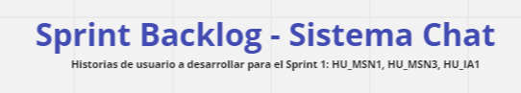

<https://miro.com/app/board/uXjVPqnohBw=/?share_link_id=747177376266>

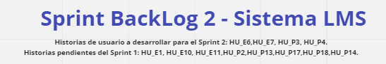

<https://miro.com/app/board/uXjVPqnohBw=/?share_link_id=747177376266>

# Scrum Board

## Subsistema - MSN

<https://scrummasters3.atlassian.net/jira/core/projects/MSN/board>

## Subsistema - IA

<https://scrummasters3.atlassian.net/jira/core/projects/IA/board>  
**Subsistema - LMS(Estudiante y profesor)**

[**https://tree.taiga.io/project/pipefake-lms/taskboard/sprint-2-2417**](https://tree.taiga.io/project/pipefake-lms/taskboard/sprint-2-2417)

# KPIs

## Burndown Chart

<https://docs.google.com/spreadsheets/d/1iY7uBg9IS1aC8remZ5pDoLkGeUyyEPrc/edit?usp=share_link&ouid=104223965947422982072&rtpof=true&sd=true>

## Cycle Time Chart, Lead Time Chart y Sprint Velocity

<https://docs.google.com/spreadsheets/d/1tfLkIrmbHlddZwd2EQkO7l62LgaZrsLv/edit?usp=share_link&ouid=104223965947422982072&rtpof=true&sd=true>

# KPIs-LMS

## Burndown Chart

<https://docs.google.com/spreadsheets/d/1Lz36kB_yuZlDgj3w_6VchYB5jQhE-c_D5FT5KWbOT_A/edit#gid=2101875864>

## Cycle Time Chart, Lead Time Chart y Sprint Velocity

<https://docs.google.com/spreadsheets/d/1Lz36kB_yuZlDgj3w_6VchYB5jQhE-c_D5FT5KWbOT_A/edit#gid=1259162391>